Ideation Phase

Empathize & Discover

Date | 11th October 2026
Team ID | Servicenow - A2
Project Name | Car Rental Request Automation in ServiceNow
Maximum Marks | 4 Marks

Empathy Map Canvas:
An empathy map is a simple, easy-to-digest visual that captures knowledge about a user’s behaviours and attitudes.

It is a useful tool to helps teams better understand their users.
Creating an effective solution requires understanding the true problem and the person who is experiencing it. The exercise of creating the map helps participants consider things from the user’s perspective along with his or her goals and challenges.

Example:
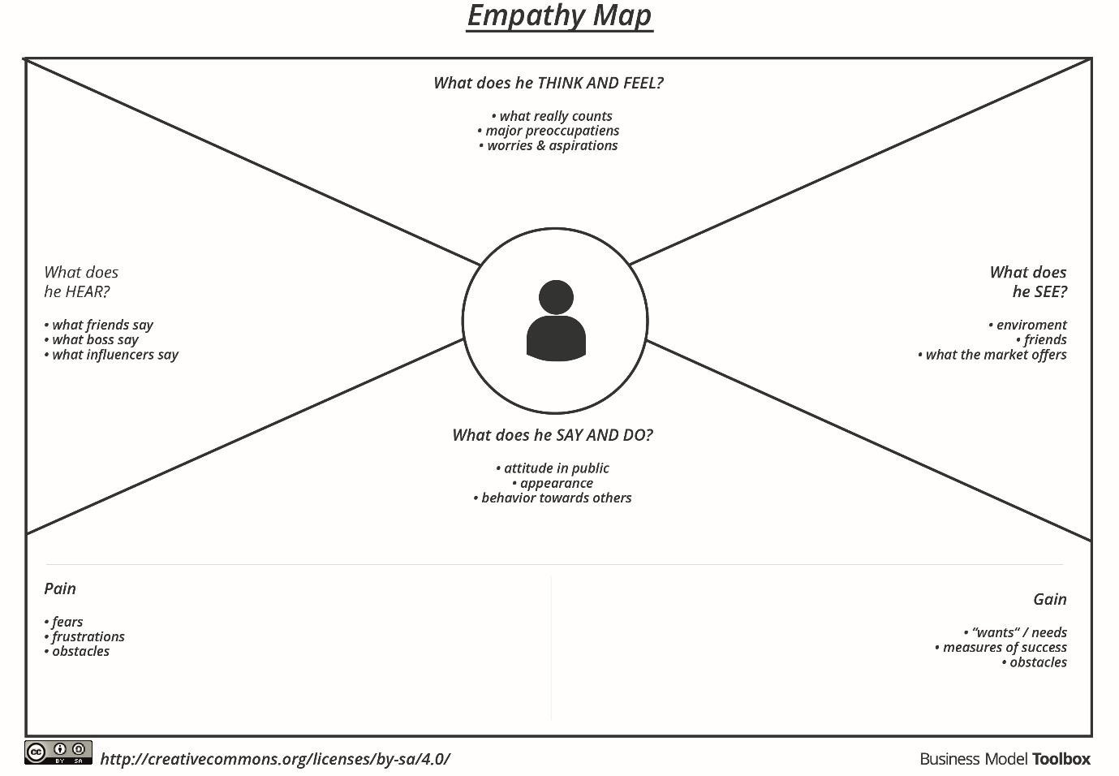

Reference: https://www.mural.co/templates/empathy-map-canvas

Example: Food Ordering & Delivery Application
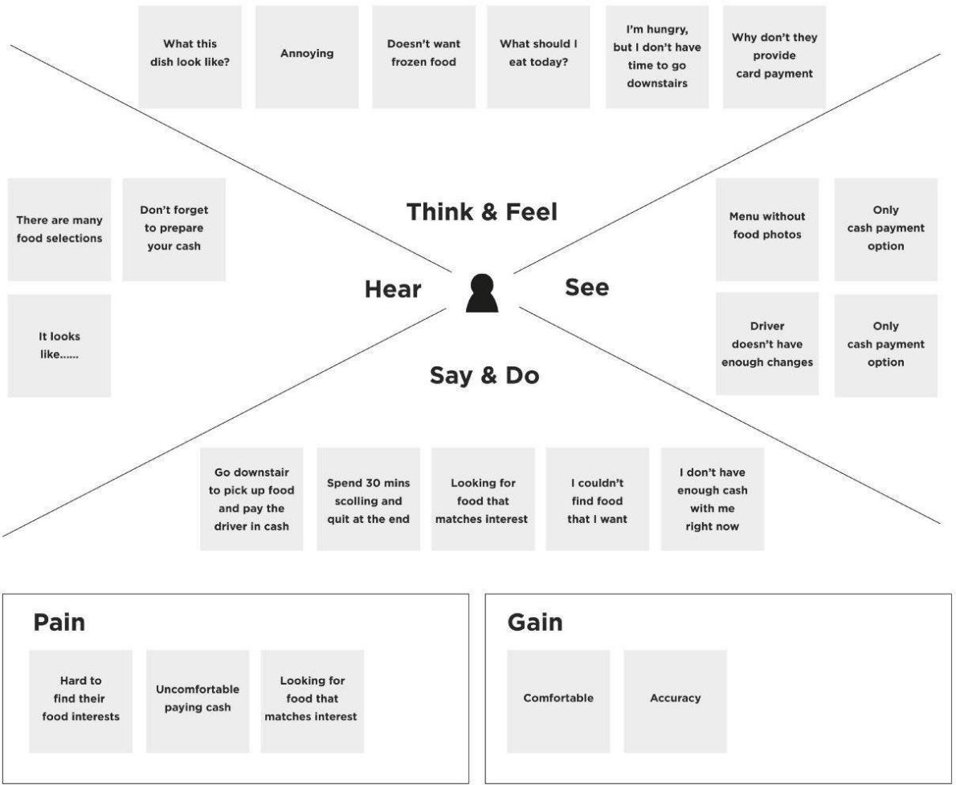

Car Rental Request – Empathy Map
Primary user: Employee requesting a rental car for official travel. The map captures the user's needs, observations, actions and emotions during the request process.

Empathy Area | User Insights
SAYS | “I need a car for my official trip.”  “I want to know whether my request is approved.”  “I should not have to repeatedly contact the transport team for updates.”
THINKS | “Did I provide all the required details?” “Is the car available for my travel dates?”  “Who is processing my request and what is the current status?”
DOES | Submits the ServiceNow catalog request; enters travel dates, pickup/drop-off information and car preference; checks the request/RITM status; responds if additional information is requested.
FEELS | Wants the process to be simple and reliable; may feel anxious when approval or vehicle availability is unclear; feels confident when the request status and notifications are clear.
PAINS | Manual emails or calls; repeated follow-ups; incomplete request information; unclear approval status; uncertainty about vehicle availability; risk of last-minute arrangements.
GAINS | One standard ServiceNow form; mandatory and clear

fields; automated approval; transport-team assignment; timely notifications; transparent RITM tracking; faster and more reliable fulfillment.

Key User Need
The employee needs a simple, transparent and automated car rental request process that confirms what was submitted, shows the approval/fulfillment status and reduces the needfor manual follow up

